Gala Dinner and Prize Giving.
Dear All,
The arrangements are now complete for the post gala dinner and prize giving. This year the format has been changed to make it more attractive for visiting swimmers. The post gala dinner will take place at 6.30pm on Saturday March 1st at the Pavilion bar and restaurant in University of Limerick. The restaurant is located across the bridge on the opposite side of the river within 5 minutes’ drive from the pool (see map below). Dinner will include main course, desert and tea/coffee at a cost €15.00 per head, payable at the restaurant cash desk.
Gala Prize giving will take place immediately after dinner. Those who wish to attend should notify the gala organiser by email at galaorganiser2014@gmail.com so the restaurant can be advised of approximate numbers.
Pavilion Bar & Restaurant
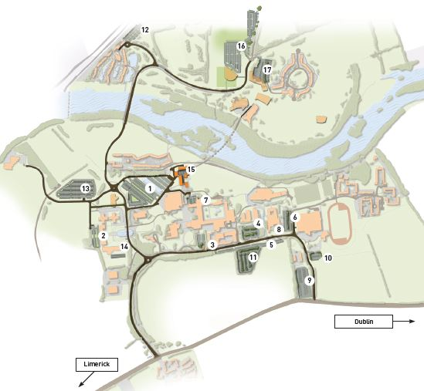
UL Arena 50m Pool

