LIMERICK MASTERS SC

IRISH OPEN LONG COURSE
MASTERS CHAMPIONSHIPS

2nd & 3rd March 2018

The University Arena
University of Limerick

Dear Masters Swimmers,

Limerick Masters SC are proud to announce that the Irish Open Long Course Masters Championships 2018 will be held at the University Arena 50m Swimming Pool, on Friday 2nd and Saturday 3rd March 2018.

Again this year we are offering a full programme of events, with the 1,500M event taking place on Friday evening, followed by a full day of swimming on Saturday. However, due to the time it takes to run the programme of events, this year we have to limit the number of entrants per event and so all individual entries will be through our on-line process only.

We hope to be able to offer all competitors the events they wish to enter and we plan to open the online entry in early December.

The closing date for the receipt of all entries is Wednesday 31st January 2018.

The post gala entertainment will be held in the Castletroy Park Hotel and we invite you all to join us there. More details to come on our website – www.limerickmasters.com

I look forward to welcoming you all back to Limerick City for this premier Masters Swimming event in 2018.

Andrea Newport
Chairperson
Limerick Masters SC

CLOSING DATE
Wednesday 31st January 2018
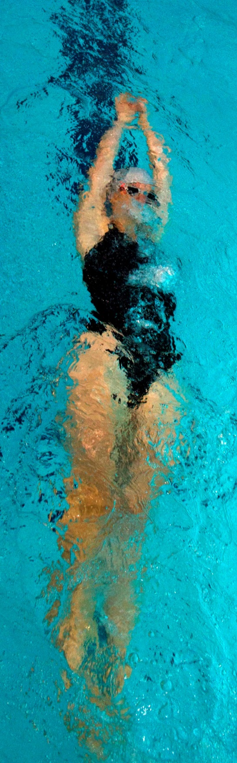

SCHEDULE OF EVENTS

Session 1: Friday 2nd March 7:00pm to 10:00pm
- Mixed 1500m Freestyle.
Session 2: Saturday 3rd March 8:30am to 1:00pm
- Mixed 400m Freestyle
- Mixed 50m Breaststroke
- Mixed 200m Individual Medley
- Mixed 100m Backstroke
- Mixed 200m Freestyle
- Mixed 100m Butterfly
- Mixed 50m Backstroke
- Men 4*100m Medley Relays
- Women 4*100m Medley Relay
- Mixed 4*100m Medley Relay
- Mixed 800m Freestyle
Session 3: Saturday 3rd March 2:00pm to 5:00pm
- Mixed 100m Freestyle
- Mixed 200m Breaststroke
- Mixed 50m Butterfly
- Mixed 200m Backstroke
- Mixed 100m Breaststroke
- Mixed 200m Butterfly
- Mixed 50m Freestyle
- Men 4*100m Freestyle Relays
- Women 4*100m Freestyle Relay
- Mixed 4*100m Freestyle Relay
ENTRIES

- All Individual entries are through online entry only at http://limerickmasters.com/

- Postal entry will only be accepted for Relay entries. Relay entries will be accepted on the day – before 10am for the Medley Relay events and before 2pm for the Freestyle Relay events.
Please send cheque or Postal Order to;
Gala Organiser Limerick Masters SC
7 The Grange,
Raheen,
Limerick
Tel No: 087-9972923 (after 6pm)
Any queries, please email: galaorganiser@limerickmasters.com

EVENT CONDITIONS

General Conditions
- FINA and Swim Ireland Masters rules apply to all age groups.
- This gala is open to any swimmer who is 19 years or over on the date of the competition, and is licensed with Swim Ireland or FINA affiliate.
- Competitors may compete in as many individual gala events.
- Competitors may only compete once in each of the team events listed.
Ages
- Age as of the 31st of December 2018 determines your age group for this meet.
- The age groups for men and women individual Masters events shall be UA=(19-24), A=(25-29), B=(30-34), C=(35-39), D=(40-44), E=(45-49), F=(50-54), G=(55-59), H=(60-64), I=(65-69), J=(70-74), K=(75-79), L=(80-84), M=(85-89), N=(90-94), O=95+
- All team members in relay events must be 25 years of age in the year of the competition.
- The age group categories offered for each relay event will be 100-119, 120-159, 160-199, 200-239, 240-279, 280-319 and in 40-year increments as high as necessary years.
- The combined age of the team, in the year of the competition must fall within the age bands detailed in 8.
Individual Events
- All events will be run as mixed individual events.
- All events will be conducted on a timed final basis.
- All individual events are heat declared winner in age and gender classification.
- Individual competitors will be seeded according to their entry time and will compete against those with similar times.
- Where no entry times (NT) have been submitted, swimmers will be placed in the first heat of the particular event.
Team Events
- Mixed teams shall consist of two competitors of each sex swimming in any order.
- All team events are heat declared winner in age classification.
- A swimmer in a team event must be entered in at least one individual event.
- A swimmer entered in the name of one club in the individual events may not compete in the name of another club in the team event.
- The names of swimmers in relay teams and the order of swimming must be reported to the Relay Coordinator by 10am for Medley events and by 2pm for Freestyle events.

Registration
- All competitors must be a member of Swim Ireland or equivalent prior to the day of the competition. Your registration number must be supplied with your entry.
- Competitors who are not members of Swim Ireland or FINA affiliate, there is the opportunity to take out a Swim Ireland Special Membership, which allows individuals the opportunity to become a Swim Ireland member and compete in specific events previously only open to club members. Please contact Swim Ireland at www.swimireland.ie
Entries
- All entries must be received by the Gala Organiser by the gala published closing date.
- Late, incomplete or incorrect entries will not be accepted.
- Entry confirmations will not be sent out.
- The Gala Organiser reserves the right to accept late entries.
- Entry fees are non-refundable.
Competitors with a Disability
- A competitor who has a permanent disability shall not be disqualified in a case where his disability prevents him from complying with the rules of a particular stroke, provided that the disability has been notified to the gala referee by the competitor or his representative before the event takes place.
- Notification shall be by a medical certificate issued by Swim Ireland approved Medical Officer.
Safety
- All competitors are required to ensure that they observe all safety announcements and conduct themselves with safety in mind at all times.
Awards
- Medals shall be awarded to the first three placed swimmers and teams in each event in each age group.
- The Limerick Masters 1500 Trophy will be awarded to the 1500m Freestyle competitor who achieves the closest time to the current world record time in his or her age category.
- The Limerick Masters 50 Trophy will be awarded to the 50m Freestyle competitor who achieves the closest time to the current world record time in his or her age category.
- The Jim Neylon Limerick Masters Trophy will be awarded to the 50m Breaststroke competitor who achieves the closest time to the current world record time in his or her age category
- Awards to The Best Overseas Female Competitor, Best Overseas Male Competitor, Best Irish Female Competitor, Best Irish Male Competitor will be based on the cumulative points scored throughout the gala.
- The Best Team Award will be awarded based on the cumulative team points scored throughout the gala.
- The Best Overseas Team Award will be awarded based on the cumulative team points scored throughout the gala.

Special Arrangements
- Qualifying Times: Age and gender based qualifying times may need to be applied in the 400M, 800M and 1500M Free Style events. Qualifying times will be posted on the Limerick Masters web site.
- A number of events will be limited and will be on a first come first served basis through on-line entry only
- All competitors in the 1500m, 800m and 400m will receive confirmation of their entry one week prior to the event.
- All competitors in the 1500m Freestyle event must register with the Gala Organiser on the pool deck on or before 6.15pm on the day of the event. If you are not registered by 6.15pm, your place may be given to a swimmer on the waiting list.
- For the 1500m Freestyle event, the Gala Organiser reserves the right to hold a list of possible late entries and should competitors not register before the deadline, the gala organiser reserves the right to deck seed the event and slot in the swimmers from the late entry list.
- The 1500m event will run in the order of slowest to fastest heats but the Gala Organiser reserves the right to run in the order of fastest to slowest heats.
- 800m & 400m Deck Seeding: The gala organiser reserves the right to deck seed these events.
- No team entries will be accepted on the day of the gala.
- Each team event is restricted to 10 teams and entry confirmation be allocated on a first come first served basis.
- A detailed gala program will be available at www.limerickmasters.com two days in advance of the Championships.

EVENT INFORMATION

Venue
University Arena
National 50m Pool
University of Limerick
Tel No: +353-(0)61-213519

Hotels
View a full list of Limerick hotels at booking.com
http://www.booking.com/

Things to do in Limerick
Check the following links……
http://www.limerick.ie/
http://www.tripadvisor.ie/

